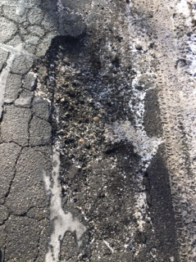
3 Ways Winter Weather Affects Asphalt?

Whether we are in the middle of an above-normal temperature pattern or expecting a cold and blustery storm, the winter weather in New England has the potential to have damaging effects on your parking lot. Here are 3 main areas to be concerned about and how to prevent future damage:
- Fluctuating Temperatures
One of the main problems affecting asphalt in the winter is the fluctuating temperatures. The varying temperatures will cause any outside material to expand and contract at different rates. For instance, asphalt is denser and carry’s less water than the ground so there is less expansion. In contrast, the ground is not as dense as asphalt and will contain more water and have a wider range of expansion. The disparity in expansion rates can cause tension with the asphalt and support system. If not installed correctly, the asphalt will eventually form cracks and potholes. Be sure to have the asphalt inspected for problems before temperatures start dropping.
Frost heaves

If cracks in the asphalt are not property maintained, you will have a higher rate of expansion and contraction leading to Frost Heaves. Here’s how they develop:
- With winter rains or melting snow, the water seeps into the asphalt cracks
- As the temps fall below freezing, the water expands 9% due to hydrogen-bonds forming between the water molecules.
- The expansion forces the asphalt to crack and deteriorate.
- Rising temps mean ice in the cracks now turns into water which penetrates further into the enlarged opening setting up more damage.
- Once the temperatures fall again, the process will repeat itself.
Research shows that cracksealing asphalt can save between 5-8 years onto your parking lot and possibly more if you add sealcoating every three years. Use a reputable product and company to apply it correctly.

- Potholes 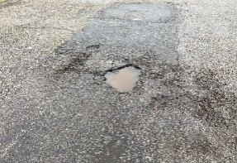
As the winter transitions to spring you may find more potholes appearing and ask yourself why? It is because the asphalt has been rising and falling during the repeated freeze/thaw cycles. This action causes a space to form below the asphalt surface, and with even minor traffic, the asphalt will weaken, collapse, and a pothole will appear. Please be sure inspect your lot thoroughly before the winter storms arrive to reduce the chances of water getting into your sub-base. It might even be necessary to patch “problem” areas or clean out the catch basins beforehand.

As with any significant part of your property management responsibilities, be sure to work with a professional asphalt maintenance company to ensure the best possible outcome for your parking lot. Contact T&K Asphalt at www.tkasphalt.com if looking for a plan to protect your asphalt and eliminate problem areas.

